s
Qualification and Certifications :

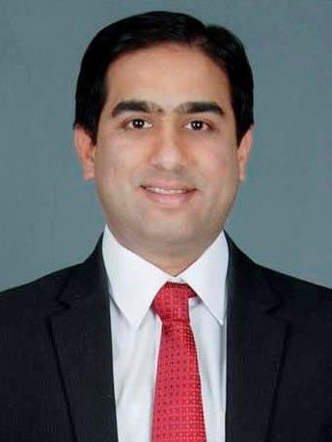
Girish Vk
Trainer , Coach , Facilitator

Profile Brief:
A result driven professional with over 21+ years of consulting and training experience. Successful track record of providing innovative trainings and advisory services in the area of training and organizational development. Provided trainings pan India and few projects abroad, having delivered over 17000 hours of training in the areas of Leadership Development, Life skills, MDPs, Business Communication, Soft Skills and Theater/Drama based workshops etc .
As a Facilitator, trainer and coach, my focus is on empowering individuals in the public and private sector the opportunity to sharpen their skills and improve their performance to build positive, steady, measurable results for their organization.

Expertise : Training Needs Assessment, Facilitating Leadership Development workshops, Designing and Managing Organization Development initiaves , interventions and customized training programs, Designing and delivering drama based workshops.

Interests:
Travelling, understanding new people and places, Dramatics, Reading, Writing short stories, poems . Have received awards and accolades at various inter college festivals pan India.
Trained in Drama / Theater with Padma Bhushan Mr. Anupam Kher (Veteran superstar from Hindi drama and films),Padma Bhushan Mr Naseeruddin Shah (Veteran superstar from Hindi drama and films), Padma Bhushan (Lt) Pandit Satyadev Dubey and Mr. Sharad Ponkshe (leading Marathi drama and film actor).

Education and Training Certifications:

Education :
- B.E (Civil) from MIT Engineering College-University of Pune
- MMS (Master in Management Science) (Merit List Holder) - University of Pune

Training Certifications:
- Certified Facilitator from Dale Carnegie Training
- WCT (WNS Certified Trainer) (Certified)
- Coaching Certification – Erickson Coaching International ( Accredited to International Coaching Federation)
- Certified NLP Practitioner from ANLP, India
- Certified NLP Master Practitioner, ANLP, India
- Certified Hypnotist, ANLP India
- Certified Advanced Life Coach, ANLP India
- Certified Reiki Practitioner-Level 1-USUI System of Natural Healing-Mahavatar Babaji TadEkam Foundation

Clients ( Partial List) :

Manufacturing /Engineering
- Behr India Ltd ( Formerly Mahle Behr Group)
- Badve Group – Engineering & Autocomp
- Emerson Innovation Center
- Cee Dee Vacuum Equipment Pvt ltd
- Knorre Bremse
- Varroc
- LEAR Corporation
- Emerson Virgo
- Nirmal Industrial Controls
- Takshi Auto Components Pvt Ltd

Government / PSU / Government Undertaking / International
- GALFAR-SAOG(Sultanate of Oman)
- State Government of Maharashtra – Konkan Division
- Institute of Chartered Accountants of India ( ICAI)
- ICSI ( Institute of Company Secretaries of India)
- MUHS ( Maharashtra University of Health Sciences) ( Government of Maharashtra)
- ARAI ( Automotive Research Association of India)
- State Government of Madhya Pradesh – Education Department

IT / ITES
- L & T Infotech
- Capgemini
- FIS Global
- HSBC GLT
- Sciformix
- Avalara Technologies
- Neeyamo Technologies
- Cross Country Healthcare
- Phoebus Media
- Verinite

Education
- Symbiosis Group
- NICMAR ( National Institute of Construction Management & Research)
- KIITS University, Bhubaneshwar
- MIT College of Management
- MIT School of Business
- K K Wagh College of Engineering, Nasik
- Indira School of Management
- Times & Trends Academy
- Infini Institute of Program Management
- DIMR
- Moze College of Engineering

Others
- Sakal Media Group
- TJSB ( Thane Janata Sahakari Bank)
- TATA AIA
- BNI Pune West
- BBNG
- Architects United

Professional Background:

December 2013 onward : Established Nallanda Bizness Associates-a proprietary firm in the area of Corporate Training, Coaching and Consulting

Aug 2002 – Oct 2013
- Senior Learning Specialist, Hitachi Consulting
- Manager, WNS Global Services
- Business Development & Training Executive, Dale Carnegie Training
- Sales Manager, Universal Construction Machinery

Awards & Recognition:
- Rank holder : 2nd in order of merit for MMS program, University of Pune & 1st in order of merit in INDSEARCH Institute, Pune
- NIRMITEE : Second prize -National Level Technical Paper Presentation competition
- Universal Construction Machinery : Best upcoming Sales Engineer
- WNS : Performance Excellence Awards
- Hitachi Consulting : Sparkle Award, Team Award

Special Recognition:
Lead Facilitator at WNS for “Train to Retain” project in 2011-12, this program was the CEO’s key project and the aim was to reduce attrition by working closely with Business Units, vertical HR teams and other stakeholders. Was able to successfully deliver results & as an overall impact of the project, attrition was reduced by 6% saving huge cost for the organization. In one of the business verticals – Finance & Accounting(F & A), attrition was reduced by 11.3%

